RESOLUTION NO.__________

RE: CERTIFICATE OF APPROPRIATENESS UNDER THE
PROVISIONS OF THE ACT OF THE PENNSYLVANIA
LEGISLATURE 1961, JUNE 13, P.L. 282 (53
SECTION 8004) AND BETHLEHEM ORDINANCE NO.
3952 AS AMENDED.

WHEREAS, it is proposed to replace the existing wooden garage doors with new metal and composite doors at the garage located to the rear of the lot at 129 E. Market St.

NOW, THEREFORE, BE IT RESOLVED by the Council of the City of Bethlehem that a Certificate of Appropriateness is hereby granted for the proposal.

Sponsored by: (s)

(s)

ADOPTED BY COUNCIL THIS DAY OF

(s)
President of Council

ATTEST:

(s)
City Clerk

HISTORICAL & ARCHITECTURAL REVIEW BOARD

The applicant is proposing to replace the existing wooden garage doors with new metal and composite doors at the garage located to the rear of the lot at 129 E. Market St.
APPLICATION #2:

Bruce & Kim Campbell
129 E. Market Street
Bethlehem, PA 18018

OWNER:

__________________________________________________________________________

The Board upon motion by Phil Roeder and seconded by Marsha Fritz adopted the proposal that City Council issue a Certificate of Appropriateness for the following:

- The doors will contain 16 glass lites in the upper section as per Coply spec sheet.

- Re-use of existing bead board facing for the finish on the drop header.

- There will be a solid panel trimmed similarly to the new door panels.

- The new door color will be Desert Tan and trim to match trim on the property.

5. The motion was unanimously approved.
__________________________________________________________________________

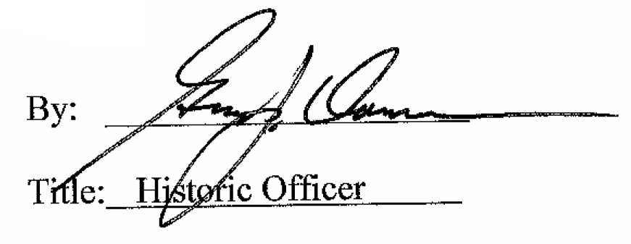

Date of Meeting: December 7, 2016

